# Using some Word functions to make life easier

Open the file “word automation-text.docx” as well as this one. Word will let you show two documents at the same time (not in windows of the same shell in the way that Excel does)

## Headings and paragraph format

On the home tab in the “styles” box

Used for creating indexes, contents sheets etc but also to format sections of the work

Type some text, select the text and choose heading 1, repeat for heading 2

A heading 1

A heading 2

The style Heading 3 should now be available as an option (it wasn’t there before). Make a heading 3 and style heading 4 will appear.

A heading 3

You don’t have to use every heading in order but it does (usually) make things easier.

## Table of contents

Now use the references tab and insert a table of contents, notice the dropdown triangle on the table of contents icon, you can have different styles of contents including manual entry

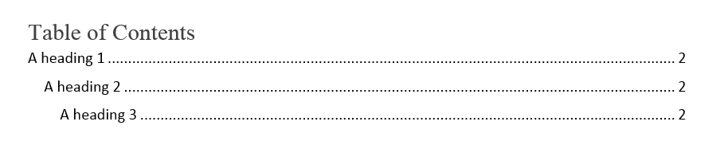

The table is not just for show, you can jump to headings or pages by ctrl-click on the text.

## Page break

Insert a page break at this point (insert tab) to make the next text start on a new page. This is in preference to using return (enter, carriage return, line feed) several times to get the page spacing correct. If you use return and then change any text before that point (or change the paper size), the page spacing will change and probably look wrong.

Put the heading 1, 2 and 3 in again

# Heading1 text

Some text

## Heading 2 text

Some more text

### Heading3 text

And some text

Notice that the next line spacing is different each time

Put a heading 4 into the document:

#### A heading 4

I am using heading 4 because it will change style as you use it.

Put another Heading 4 in the document and modify it afterwards:

#### Another heading4

Select the text of this heading and change the font to Times New Roman, size 14. Only this heading has changed.

Select the modified heading text again. Now right click on the heading 4 tab in home, styles. Choose “update heading 4 to match style”. Notice that the earlier heading 4 has also changed this time.

Insert a heading 5:



Select the text and right click the heading 5 icon in styles, choose modify. There are a lot more choices here. Notice the option to make changes only for this document or for all future documents. Click the format button and even more choices appear in a dropdown. Choose paragraph. You should be able to see options to change spacing before and after paragraph. This automatically and consistently sets the spacing around the heading5 – you don’t need to make any manual changes or try to make the match in the future, text the text on a new line, type the next paragraph on the next new line then go back and set the heading style. You can change the font, font style, colour, size in a similar way and add numbering etc. I have added Roman numbering, change the font colour and size and chosen “Small Caps”

##### A heading 5

Insert another heading 5:

##### Another heading 5

The style is immediate and the numbering is automatic

You can only have one table of contents, if you try to insert another, it should update the original. Notice that not all levels are shown when you do this.

Select the table, choose the table of contents dropdown and choose custom table of contents. Change the value of show levels to 5. Update the table and the style changes should show in the table.

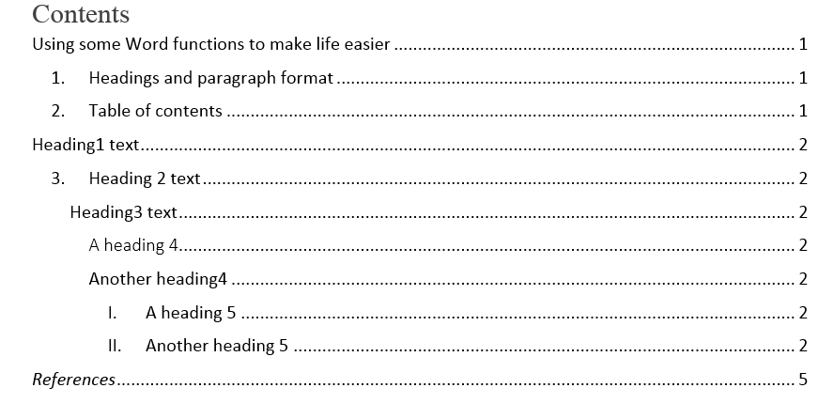

Removing a table of contents or references is not always easy – make sure to select the table and then use the dropdown “sheet” icon. At the end of the list is an option to remove table.

Paragraph styles are very similar. The following text is from a classic book “Alice in Wonderland” by Lewis Carrol. The copyright on this book expired many years ago. The paragraphs are all written in the “normal” style:

“

Alice was beginning to get very tired of sitting by her sister on the bank, and of having nothing to do: once or twice she had peeped into the book her sister was reading, but it had no pictures or conversations in it, `and what is the use of a book,’ thought Alice `without pictures or conversation?’

So she was considering in her own mind (as well as she could, for the hot day made her feel very sleepy and stupid), whether the pleasure of making a daisy-chain would be worth the trouble of getting up and picking the daisies, when suddenly a White Rabbit with pink eyes ran close by her.

There was nothing so VERY remarkable in that; nor did Alice think it so VERY much out of the way to hear the Rabbit say to itself, `Oh dear! Oh dear! I shall be late!’ (when she thought it over afterwards, it occurred to her that she ought to have wondered at this, but at the time it all seemed quite natural); but when the Rabbit actually TOOK A WATCH OUT OF ITS WAISTCOAT- POCKET, and looked at it, and then hurried on, Alice started to her feet, for it flashed across her mind that she had never before seen a rabbit with either a waistcoat-pocket, or a watch to take out of it, and burning with curiosity, she ran across the field after it, and fortunately was just in time to see it pop down a large rabbit-hole under the hedge.

In another moment down went Alice after it, never once considering how in the world she was to get out again.

The rabbit-hole went straight on like a tunnel for some way, and then dipped suddenly down, so suddenly that Alice had not a moment to think about stopping herself before she found herself falling down a very deep well.

Either the well was very deep, or she fell very slowly, for she had plenty of time as she went down to look about her and to wonder what was going to happen next. First, she tried to look down and make out what she was coming to, but it was too dark to see anything; then she looked at the sides of the well, and noticed that they were filled with cupboards and book-shelves; here and there she saw maps and pictures hung upon pegs. She took down a jar from one of the shelves as she passed; it was labelled `ORANGE MARMALADE’, but to her great disappointment it was empty: she did not like to drop the jar for fear of killing somebody, so managed to put it into one of the cupboards as she fell past it.

`Well!’ thought Alice to herself, `after such a fall as this, I shall think nothing of tumbling down stairs! How brave they’ll all think me at home! Why, I wouldn’t say anything about it, even if I fell off the top of the house!’ (Which was very likely true.)

“

It is common for Professional text to be laid out as “justified” – a combination of left and right aligned. Right click on any line in the last paragraph of the quoted text and select “paragraph”. Change the alignment from left to justified and apply the change. Only the final paragraph will be changed. Right click again in the paragraph and again select paragraph. This time add a tick to “Don’t add space between paragraphs of the same style”. Make sure that the cursor is placed in the modified paragraph then right click on the “normal” icon in the styles box on the home tab. Select “update Normal to match selection”. The whole document now changes to match the paragraph. You can create new styles by clicking the dropdown in the styles box.

## Captions and pictures

Insert a picture from the samples folder. You can resize with the “anchors”. The mid points at the top, bottom, left and right will change only one dimension resulting in a distorted image. The corner points will change both dimensions simultaneously, resizing the image but maintaining the correct aspect. Right click the image and note that you can crop an image to remove unwanted areas (really useful when you insert a copied image with a large amount of white space at one edge).

Right click the image and choose insert caption. In the caption box add the words “: a picture”, you cannot change the “figure 1” text

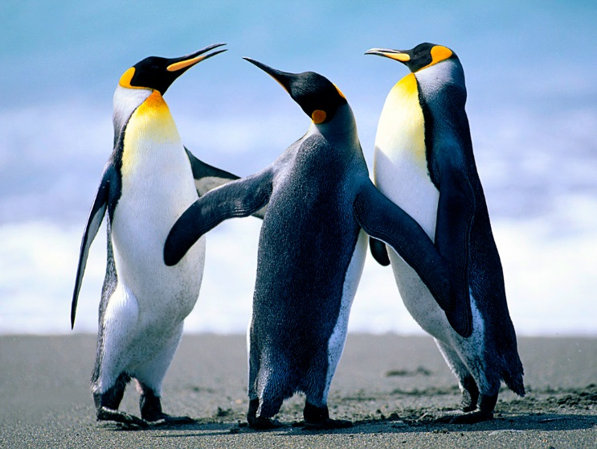

Figure 1: a picture

You can change the style in the same way as the text earlier. The caption number will increment automatically though you can modify this action.

You can add a “table of figures” with the table of contents

Tables are very similar, you can add a caption but it will normally appear above a table rather than below.

## Split captions

A common problem occurs when the caption and figure appear on different pages. Place the cursor in the margin to the left of the image, right click and select paragraph, change to the line and page break tab and make sure there is a tick in the box “keep with next”. (for tables, you need to select the caption first rather than the table)

## References

Type a section of text then add a reference. To do this, from the references tab choose insert citation. If you have already created some entries in this document they will be shown and you can simply select the appropriate one. If you have created citations previously but not in this document, you need to choose “manage sources” and copy the required entry from the left to the right box. The citation will now be available under insert citation. Alternatively, under insert citation, choose “add new source”. It is important that you choose the correct type of source, then complete the details. You can add more detail if you select “show all bibliography fields” – it could help at a future date. The reference should appear in the text like this [1]. Remember to include the reference in the sentence that it refers to i.e. before the full stop. The style of the citation is determined by the style box – Harvard and IEEE are very common at the UoD especially in EngTech [2]. If you change the style, the result [3] is immediate. Note – there are many different Harvard styles.

Insert the reference table using the dropdown “bibliography”, choose references.

Change the heading type to match the level and style required:

# References

|  |  |
| --- | --- |
| [1] | Vehicle Detector Clearinghouse, “A Summary of Vehicle Detection and Surveillance Technologies used in Intelligent Transportation Systems,” New Mexico State University, Las Cruces , 2007. |
| [2] | Science News, “Ancient Rome forbade downtown traffic in day,” *Science News,* vol. 78, no. 5, 30 July 1960. |

Notice that the title and table have split over a page. To correct this you need to modify the paragraph for the title AND the second line. Choose “keep with next” FOR BOTH LINES (otherwise the title stays with the empty line)

## Reference database

The reference database stays in the user profile on the pc that you are using unless you take a copy with you. It is normally located in <your user profile>\appdata\roaming\microsoft\bibliography and is called sources.xml

## Cross referencing

If you have created figures and tables and then refer to them in your text, they may become “out of sync” if the numbering is updated. You can prevent this by using the cross reference option in the captions group on the references tab. Choose reference type “figures” and then select the picture created earlier. Now choose “only label and number”, the following text appears: Figure 1. This can now be updated automatically – if you add new pictures before the original figure 1, it will renumber and you can automatically update your text to match (figure 1 will become figure 2, your text will also change to figure 2 if you use the update method below). You can use the cross-reference to tables, paragraphs, equations and so on.

Tables typically do not update automatically. You need to right click on the table and chose update entire table. Sometimes you might need to select everything (ctrl-a), right click and choose “update field”, this will change/correct all numbering and ordering.

## Useful shortcuts

Final comment, there are many shortcut keys accessed with ctrl- something. The most common are cut, copy, paste under ctrl-x, ctrl-c, ctrl-v. Other useful combinations are undo (ctrl-z) and redo (ctrl-y)